**A**

**MINI PROJECT REPORT ON**

**“Safe Vehicle Distance Alarm System”**

SUBMITTED TO THE SAVITRIBAI PHULE PUNE UNIVERSITY, PUNE FOR

**LP-I(Part-II IoT & ES)**

**THIRD YEAR OF ENGINEERING (COMPUTER ENGINEERING)**

**SUBMITTED BY**

1. Name: **Manish Karegaonkar** Roll No: **26**

2. Name: **Aditya Kalaskar** Roll No: **24**

3. Name: **Sagar Mahajan** Roll No: **38**

4. Name: **Om Keskar** Roll No: **28**



**DEPARTMENT OF COMPUTER ENGINEERING**

MARATHA VIDYA PRASARAK SAMAJ’S KARMAVEER ADV. BABURAO GANPATRAO THAKARE

COLLEGE OF ENGINEERING, NASHIK-13

**SAVITRIBAI PHULE PUNE UNIVERSITY 2022- 23**

# Title : Safe Vehicle Distance Alarm System

# 

**Index :**

1. **Introduction**
2. **Problem definition**
3. **Objective and scope**
4. **Hardware requirements**
5. **Steps of connection**
6. **Architecture diagram and flow diagram**
7. **Coding**
8. **Working Module Screenshot**
9. **Applications**
10. **Conclusion**
11. **References**

# Introduction:

Now a days, accidents are occurring more. many of people getting injured due to the accidents. once think, how it will be if the vehicle alerts when it comes close to another vehicles. today this project will help you to develop small prototype so that it will alerts you using Buzzer and Arduino Uno. the distance can be taken using ultrasonic sensor.

Hence we decided to come up with the safe vehicle distance alert system. it's essentially a setup which uses the popular Ultrasonic Sensor(HC-SR04), the Buzzer and an Arduino Uno to measure how much distance vehicle comes close to it. Hence collision between vehicles can be controlled.

# Problem Definition :

This project deals with the detection and management of vehicle distance and with the combined IOT technology. In Order to protect people to avoid accidents the safe vehicle distance system is important.

# Objectives & Scope :

The main aim is detection and monitoring the vehicle distance and to minimize the accidents cause due to not maintaining proper distance. To make driver aware about keeping safe distance while driving. It can be also used for real time applications for other object detection jobs.

# Hardware Requirements :

* 1. Arduino UNO
  2. Buzzer
  3. Ultrasonic Sensor
  4. Jumper wires

# Steps of Connection :

1. Gather all the components and check if buzzer and Ultrasonic sensor are working fine or not.

2. Connect the cathode of buzzer to GND & anode to 4 pin of Arduino.

3. Connect the Ultrasonic Sensor pins VCC, GND, Trigpin, Echopin to 5V, GND, 5, 6 respectively to Arduino.

4. attach Arduino to laptop

5. Run Arduino code on Arduino IDE.

# Architecture Diagram & Flow diagram :

Object Detected

Yes

No

Buzzer ON

Buzzer Off

Ultrasonic Sensor

1. **Coding :**

// defines pins numbers

#define IN4  4

const int trigPin = 5;

const int echoPin = 6;

// defines variables

long duration;

int distance = 0;

void setup() {

pinMode(trigPin, OUTPUT); // Sets the trigPin as an Output

pinMode(echoPin, INPUT); // Sets the echoPin as an Input

pinMode(4, OUTPUT);

Serial.begin(9600); // Starts the serial communication

}

void loop() {

// Clears the trigPin

digitalWrite(trigPin, LOW);

digitalWrite(trigPin, HIGH);

digitalWrite(trigPin, LOW);

// Reads the echoPin, returns the sound wave travel time in microseconds

duration = pulseIn(echoPin, HIGH);

// Calculating the distance

distance= duration*0.034/2;

// Prints the distance on the Serial Monitor

Serial.print("Distance: ");

Serial.println(distance); //distance is the returned integer, it is the distance in cm

if (distance<=10)

  {

  digitalWrite(IN4, HIGH);   // turn the LED on (HIGH is the voltage level)

  }

  else

  {

  digitalWrite(IN4, LOW);   // turn the LED on (HIGH is the voltage level)

  }

# Working Module Screenshots :

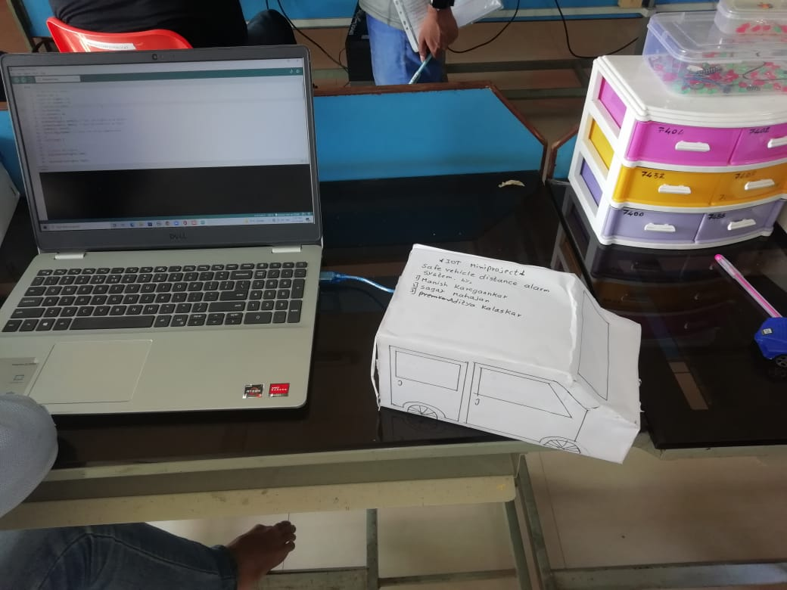

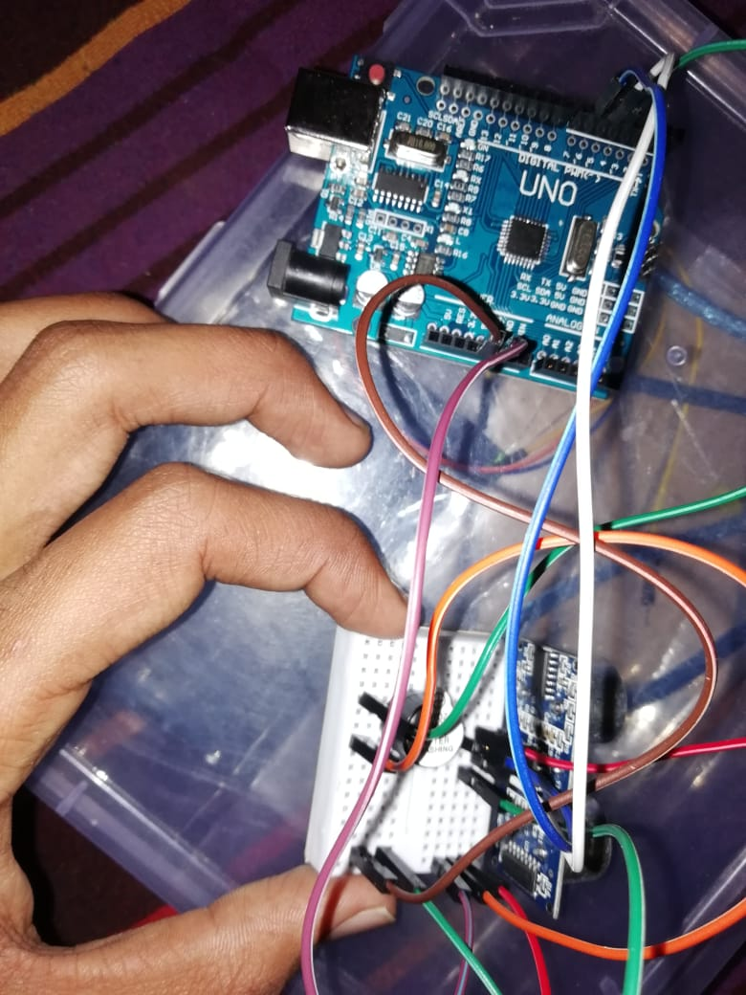

1. **Applications :**
   1. Vehicles
   2. Door locking
   3. Automatic light on system
   4. Parking
   5. Food delivery system
   6. Distance measurement systems

# Conclusion :

This type of system is the first of its kind to ensure no further damage is then to forests when there is fire breakout and immediately a message is sent to the use through the App. Immediate response or early warning to a fire breakout is mostly the only ways to avoid losses and environmental, cultural heritage damages to a great extent.

1. **References :**
2. <https://create.arduino.cc/projecthub/divya_kadava/safe-distance-alert-using-bolt-iot-092fa9>
3. <https://create.arduino.cc/projecthub/Vijendra/arduino-based-collision-detection-warning-system-d1beec>